 | Press release. Paris, September 14 2016
« Inventons la Métropole du Grand Paris »
« Let’s reinvent the Greater Paris Metropole »
The final selection of the metropolitan sites up for bids coming up shortly

Benefiting from its 7 million inhabitants and its entrepreneurial attractiveness, the largest French metropolis launched on February 18th an international bid for the development of the quality of urban life, by creating new innovative spaces, and inventing a smarter and more sustainable city model. For the first time, mayors gathered to simultaneously launch these projects at multiple points of the Metropole. This call for unique and innovative projects is consistent with the metropolitan identity that is being built and will propose concrete and new solutions to social and urban mutation challenges, as well as environmental emergency and adaptation to climate changes in the wake of the COP 21. This project thus reflects a more resilient metropolis.

The mayors of the Metropole bring forth lands under their control and will convey them to the companies presenting the best projects, after a jury deliberation. The bid is launched in an "open innovation" spirit and is open to all players who wish to invent the city of tomorrow: architects, planners, developers, investors, startups and even civic associations or communities. They will be free to provide group responses, and to bring up new competitive ideas on mixed-uses development, architecture and urban planning, environmental exemplarity and social innovation. Their creativity may rely on citizen participation and expand to the functions of mobility, logistics or digital, as well as cultural and sports offers. This bid is directed towards talents of all nationalities.

Visiting campaign during the summer 2016
During the summer 2016, the Metropole elected officials were on the field and they have now visited most of the 112 candidate sites. They already went across all territories of the Metropole, including the surroundings of Evry.

Exceptional sites are under consideration, with the opportunity to invent new neighborhoods around train stations that will punctuate the 200kms of the future subway line being built around Paris. Companies will also find unique sites conveying the soul of the Metropole, in the heart of the cities, by riversides, in old forts, as well as in evolving activity zones.

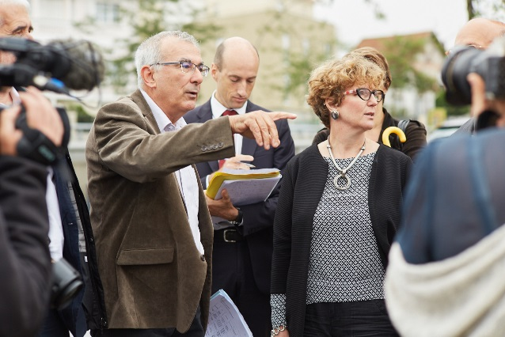  Candidate site visit in the city of Arcueil | 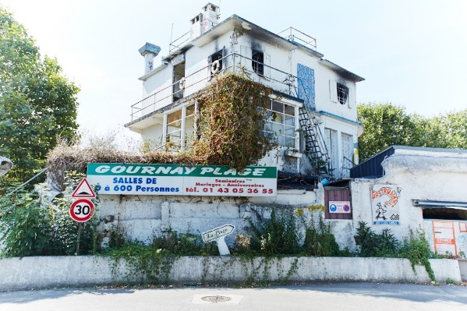  Candidate site in the city of Gournay-sur-Marne
MEETING DAY :
OCTOBER 10 AT PAVILLON BALTARD

Throughout the month of September, applications will be reviewed by the Selection Committee and the full list of sites selected will be announced on October 10.

A special day of meetings and debates will be held for this purpose at the Pavillon Baltard in Nogent-sur-Marne, so that companies can discover the sites and exchange with the mayors on their specificities. Companies with special interests will be provided with a schedule in order to visit the sites that appeal to them.

To join this exceptional meeting day, companies can now register on : www.inventonsmgp.fr

For more information or if you wish to cover this event, please find below our press contact details

About the Métropole du Grand Paris :
The Métropole du Grand Paris, created on January 1, 2016, is a public institution for inter-municipal cooperation, chaired by Patrick Ollier. It brings together 131 cities (including Paris, the municipalities in 3 departments of the inner suburbs, Argenteuil, and the cities of the urban community Les Portes de l’Essonne). Altogether, the municipalities hold 7 million inhabitants, making Greater Paris Metropole the largest French metropole. The Métropole du Grand Paris is intended to manage the inter-municipal cooperation on the 4 following levels :
o economic, social and cultural planning and development
o the protection and enhancement of the environment and the living environment policy
o the development of the metropolitan area (starting from January 1, 2017)
o the local housing policy (starting from January 1, 2017)

